Political Cartoons

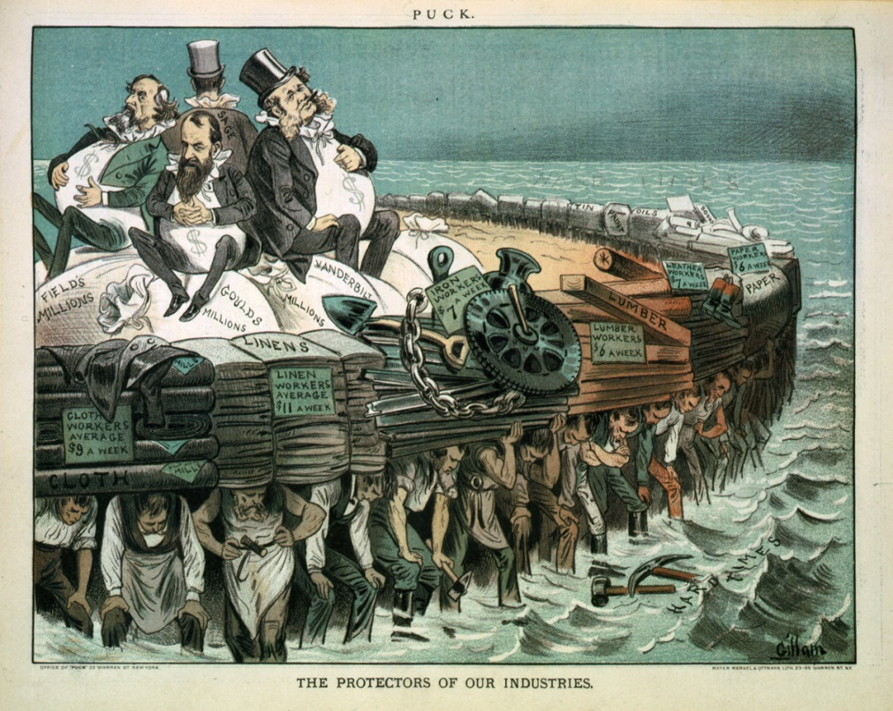

“The Protectors of Our Industries”
1883
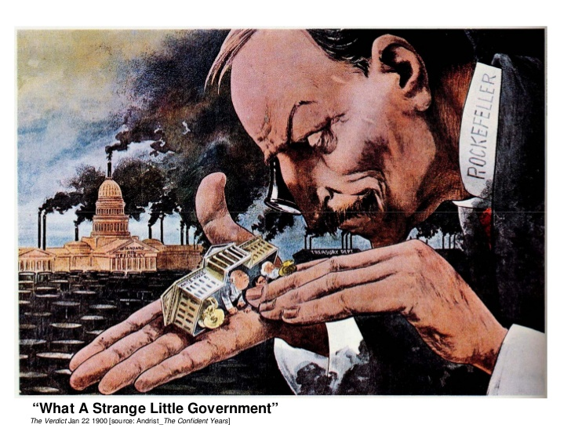
“What a Strange Little Government”
1900
Questions

Answer the following questions for EACH of the political cartoons. (10 questions total). Please write on your own piece of paper. Do not write on this sheet!

- What do you see? List 10 details.

- What message do you think the artist is trying to get across? What is its purpose?

- Who do you think the intended audience was?

- Do you think this cartoon is in support of or against American industry? Give at least 2 specific reasons.

- Generate 2 questions about this cartoon. What questions did you have while looking at it, or what else would you like to know about this work?

