Name
Period
BOP Week 7
10/3
According to Graph 1:
1.Who is least likely to vote?
2. Why do you think this demographic is least likely to vote? 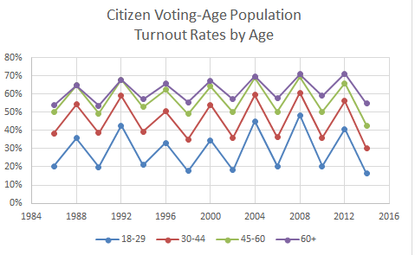
According to Graph 2:
1.Who is least likely to vote?
2. Why do you think this demographic is least likely to vote?
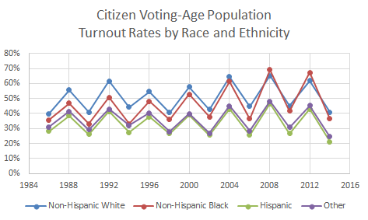
10/4
In YOUR OWN WORDS, write down the author’s main idea of the first paragraph.

10/5
- Why would I have you watch this video?
  - https://www.youtube.com/watch?v=K6CBzZ824eg
- What is the benefit of researching the author of an article?
- Write a 1-2 sentence reaction to the video you viewed.

